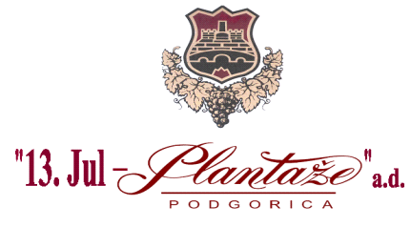
No: 841/2
Podgorica, 20.03.2026
AMENDMENTS
Request for the Collection of the Bids for Procedure of Procurement of Bottles
No.841/1, dated from 20.03.2026
Procurer modifies in the text of the Request on page 6 of the Request- technical characteristics or specification of the subject matter of procurement, for Lot 1: bottles for wine 0,75 L (model 1), and for the Lot 12: bottles for sparkling wine 0,75L CUVEE in the manner as it follows:
Instead of the text:
Lot 1: Bottles for wine 0,75 L (model 1)
Ord.No. | Description of the subject of the procurement, ie a part of the subject of procurement | Important characteristics of the subject of the procurement concerning quality, performances and/or measures | Unit of measure | Quantity
1 | Bottle for wine  0,75L olive  (model 1) | Colour- dark green-olive  Height-314±1,9mm  Weight-450 gr  Diameter -73,2±1,4mm  Closure type-corkstopper  Neck marking -band  Un.neck diameter-18,5±0,5  Middle neck diameter-28,5±0,5mm  Outer neck diameter -29,5±0,5mm  Min.passing through neck-16,5mm  Nominal volume -750±10ml  Volume up the top -770ml | 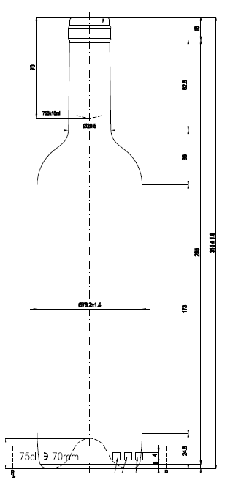 | pc | 1,695.000

the following text should be written:
Ord.No. | Description of the subject of the procurement, ie a part of the subject of procurement | Important characteristics of the subject of the procurement concerning quality, performances and/or measures | Unit of measure | Quantity
1 | Bottle for wine  0,75L olive  (model 1) | Colour- dark green-olive  Height-316±1,9mm  Weight-470 gr  Diameter -73,8±1,4mm  Closure type-corkstopper  Neck marking - BM17,5,CE.T.I.E GME50.1  Un.neck diameter-17,5±0,5  Middle neck diameter-27,5±0,5mm  Outer neck diameter -29,0±0,5mm  Min.passing through neck-16,5mm  Nominal volume -750±10ml  Volume up the top -770ml |  | pc | 1,695.000

Instead of the text:

LOT 12: Bottles for sparkling wine 0,75L CUVEE

Ord.No. | Description of the subject of the procurement, ie a part of the subject of procurement | Important characteristics of the subject of the procurement concerning quality, performances and/or measures | Unit of measure | Quantity

1 | Bottle for sparkling wines 0,75L  dark green Champagne | Colour- dark green  Height-300±1,9mm  Weight-835±10 gr  Diameter -88±1,5mm  Closure type- corkstopper  Neck marking –CE.T.I.E GME  Un.neck diameter-17,6±0,4mm  Middle neck diameter 29±0,3mm  Outer neck diameter  33,6±0,5mm  Min.passing through neck-  17,7 mm  Nominal volume -750±10ml  Volume up the top-770ml±10ml  CO₂ content-≤ 12g/L  Closing pressure -300daN | 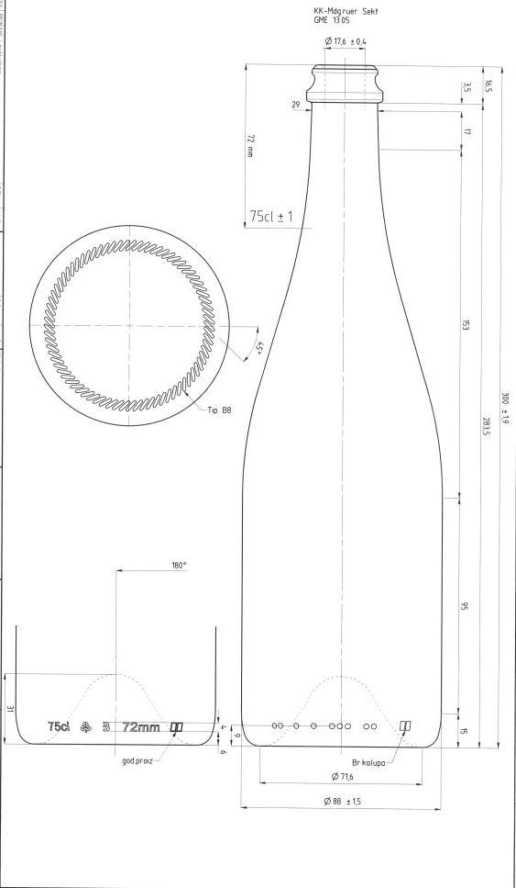 | pc | 40.000

The following text should be written:
LOT 12: Bottles for sparkling wine 0,75L CUVEE

Ord.No. | Description of the subject of the procurement, ie a part of the subject of procurement | Important characteristics of the subject of the procurement concerning quality, performances and/or measures | Unit of measure | Quantity

1 | Bottle for sparkling wines 0,75L  dark green  (Antigue green/olive/  alta protezione  Giallo) | Colour- dark green  Height-300±1,9mm  Weight-835±10 gr  Diameter -88±1,5mm  Closure type- corkstopper  Neck marking –CE.T.I.E GME  Un.neck diameter-17,6±0,4mm  Middle neck diameter 29±0,3mm  Outer neck diameter  33,6±0,5mm  Min.passing through neck-  17,7 mm  Nominal volume -750±10ml  Volume up the top-770ml±10ml  CO₂ content-≤ 12g/L  Closing pressure -300daN |  | pc | 40.000

Chairman of the Committee
for opening and evaluation of the bids,
Bojan Gašović

