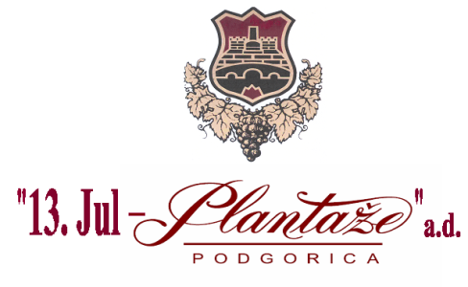

**No: 3575 /2**

**Podgorica, 05/07/2022**

**MODIFICATIONS AND AMENDMENTS**

**of the Request for Collecting the Bids for Procurement of Wooden Alternatives for Wine Correction No. 3575/1, dated from 27/06/2022 for the procurement of wooden alternatives for wine correction**

Procurer makes the amendments in the text of the Procurer’s Request ,on page 4/17 of the Request- Language of the Bid, as it follows:

**Instead of the text:**

|  |
| --- |
| **IX Language of the bid** |

**x** Montenegrin language and other language in official use in Montenegro in accordance with

the Constitution and Law

**x** English

**The following text should be written:**

|  |
| --- |
| **IX Language of the bid** |

**x** Montenegrin language and other language in official use in Montenegro in accordance with

the Constitution and Law

**x** English

**x** language in the official use in the territory of the country ,where the Bidder’s seat is located.

**Head of the Committee for**

**opening and evaluation of the bids**

**Milena Mugoša**