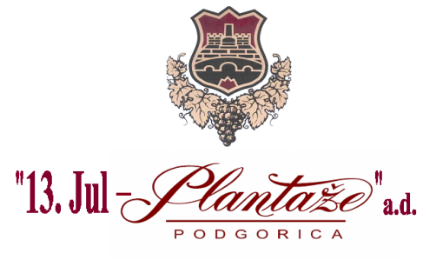
Number: 4364/2
Podgorica, 26.07.2021

MODIFICATIONS

of the Request for Collecting the Bids No. 4364/1, dated from 02.07.2021 for the procedure of procurement of goods- corkstoppers by lots-

The specification of the products in Lot 1, as well as the time limit for submitting and opening of the bids, have been modified in the text of the Request, as follows:

Modification No.1
Instead of the text:

Ord.No. | Description of the subject of procurement, ie part of the subject of procurement | Relevant characteristics of the subject of procurement, concerning quality, performance and/or measures | Unit measure | Quantity
1 | Cork stopper(agglomerate) | Height:44.0+ 0,4 mm;  Diameter:24,2 + 0,3 mm;  Elasticity (turning stopper back into previous position after corking):  > 96% / 30s;  Moisture : 2 - 6 %;  Cork stopper manufacturing: the cork stopper is made of purified micro granulate with infused micro gas bubbles, granulometry 1-1,5 mm and adhesive without silicon;  Dust content:< 0,3 mg/cork;  TCA presence:< 0,5 ng/l per cork  Peroxide presence: < 0,1 mg/ cork; : Oxygen permeability < 0,35 cm3/day;  Company logo : by toasting | pc | 3.150.000
The following text should be written:

Ord.No. | Description of the subject of procurement, ie part of the subject of procurement | Relevant characteristics of the subject of procurement, concerning quality, performance and/or measures | Unit measure | Quantity
1 | Cork stopper(agglomerate) | Height:44.0+ 0,5 mm;  Diameter:24 + 0,3 mm;  Elasticity (turning stopper back into previous position after corking):  > 96% / 30s;  Moisture : 2 - 8 %;  Cork stopper manufacturing: the cork stopper is made of purified micro granulate with infused micro gas bubbles, granulometry 0.5-1,5 mm and adhesive without silicon;  Dust content:< 1 mg/cork;  TCA presence:< 0,5 ng/l per cork  Peroxide presence: < 0,2 mg/ cork; : Oxygen permeability < 0,35cm3/day;  Company logo : print/by toasting | pc | 3.150.000

Modification No.2

Instead of the text:

VIII Time limit and place of submitting the bids and opening of the bids
The bids shall be submitted on working days from 08:00 to 14:00 hrs, closing on 30/07/2021 by 12:00 hrs.

The bids may be submitted:
□ x directly, in person at the Procurer’s archive to the following address: Put Radomira Ivanovića No.2, Podgorica.

□x by registered mail with the advice of receipt to the following address: Put Radomira Ivanovića No.2, Podgorica.

Public opening of the bid, which may be attended by the authorized representatives of the bidders with enclosed power of attorney, signed by the authorized person, will be held on the 30th of July,2021 at 12:30 hrs, in the premises of 13. jul-Plantaže a.d., located in Put Radomira Ivanovića Str, No.2, 81 000 Podgorica.
The following text should be written:

VIII Time limit and place of submitting the bids and opening of the bids
The bids shall be submitted on working days from 08:00 to 14:00 hrs, closing on 10/08/2021 by 12:00 hrs.

The bids may be submitted:
□ x directly, in person at the Procurer’s archive to the following address: Put Radomira Ivanovića No.2, Podgorica.

□x by registered mail with the advice of receipt to the following address: Put Radomira Ivanovića No.2, Podgorica.

Public opening of the bid, which may be attended by the authorized representatives of the bidders with enclosed power of attorney, signed by the authorized person, will be held on 10/08/2021 at 12:30 hrs, in the premises of 13. jul-Plantaže a.d., located in Put Radomira Ivanovića Str, No.2, 81 000 Podgorica.

Head of the Committee
for opening and evaluation of the bids
Bojan Gašović

