13. Jul-Plantaže ad Podgorica

No: 3004/1

Place and date: Podgorica, 19.04.2021.

REQUEST FOR COLECTION OF THE BIDS FOR
THE PROCUREMENT PROCEDURE
of the galvanized steel wire, galvanized steel posts
and reinforcing bar

I Data on the Procurer

Procurer:  13.Jul- Plantaže a.d. | Contact person:  Committee, presided by Milena Đurović
Address: Put Radomira Ivanovića br.2 | Postal No. 81000
Main office: Podgorica | Fiscal Ident.No.(Comp.Reg.No.).  02016281
Tel: 0038220658 051 | Fax: 00382 20 658 051
E-mail:
milena.bakocevic@gmail.com

II Subject of the procurement

- Type of the public procurement subject

x Goods
- Description of the procurement subject

Procurement of the galvanized steel wire ,galvanized steel posts and reinforcing bar for establishing of new plantations.

III Manner of the determination of the subject and assessed value of the procurement
□ Assessed value of the procurement subject
The procurement subject is procured:
x By lots:
Lot 1:galvanized steel posts of the assessed value, without included VAT, €146.100,00 , with the included VAT the amount of €176.781,00.
Lot 2: galvanized steel wire of the assessed value, without included VAT € 62.405,00 with the included VAT amounts to € 75.510,05. .
Lot 3: reinforcing bar of the assessed value without included VAT € 75.000,00 with included VAT € 90.750,00.
TOTAL:
VAT not included: € 283.505,00
with VAT included: € 343.041,05

IV Conditions for taking part in the procurement procedure

a) Compulsory conditions
Only a bidder who meets the following requirements may take part in the procurement procedure :
- Must be registered with the competent public authority for the registration of the business entities;
- Must prove that he or his legal representative has not been convicted by judgement absolute for any criminal offence as members of the organized crime with the corruption, money laundry and fraud;

Proof of the fulfillment of the compulsory conditions
The fulfillment of the compulsory conditions shall be proved by submitting the following proofs:
- Proof on the registration with the competent public authority for the registration of the business entities with the data on the authorized persons of the bidder;
- Proof by the competent authority, issued on the grounds of the criminal record which must not be older than 6 months by the day of public opening of the bids;

b) Facultative conditions

b2) professional-technical and human resources capacity
Whether conditions of professional-technical and human resources capacity are met in the public procurement procedure for goods is evidenced by submitting one or more evidences, and so as follows:
x the list of main deliveries, made in previous two years, with values, dates and receivers, with enclosing the confirmations of the effected deliveries, issued by Procurer or in case that the confirmations cannot be provided for the reasons, not caused by bidder, only the statement of the bidder on the effected deliveries with the statement of the reasons for which they cannot submit the confirmations,
x samples, descriptions, ie photos of the goods which are the subject of the delivery and the authenticity of which the bidder is obliged to confirm , in case that the Procurer requires it :

Bidder is obliged to enclose, on the memorandum of the producer, for Lot 1 only, against the bid, the technical sheet of the post that he offers, corresponding to the drawing, found in the part ‘technical characteristics or specifications of the subject of the public procurement, ie bill of quantities’.
The technical sheet of the post must be signed and sealed by bidder.

□x measures for providing the quality management system:

ISO 9001 standard

V Validity period of the bid

Validity period of the bid is 60 days from the day of the public opening of the bids.

VI Time limit and place of execution of the Contract

- Time limit for the execution of the Contract is 120 days from the day of the conclusion of the Contract.
- Time limit of delivery: successively, within the period from 01.06.2021 to 01.07.2021.
- Manner of delivery: successively in accordance with the needs of the Procurer
-The place of the execution of the Contract is Procurer’s warehouse Podgorica.

VII Language of the bid

x Montenegrin language and other language, used officially in Montenegro in accordance with the Constitution and law
x English

VIII Criteria for the selection of the most favourable bid:

Criteria for the selection of the most favourable bid for Lot 1 and Lot 2 is:

□x economically the most favourable offer
1. Functional characteristics of the products- 20 points
2. Guarantee time limit- 10 points
3. Price- 70 points

Category 1 will be scored as follows:
-zinc coating per mm²- 10 points
-design and thickness of the galvanized steel post- 10 points
Lot 2: -zinc coating per mm²- 20 points

Category 2 will be calculated by the formula: X offered/X max * number of points
Category 3 will be calculated by the formula:C the lowest price/ C offered price * number of points
Criteria for the selection of the most favourable bid for the Lot 3 is:

x the lowest offered price 100 points

Category will be calculated by the formula:C the lowest price/ C offered price * number of points.

IX Time limit and place of submitting the bids and opening of the bids

The bids shall be submitted on working days from 7 to 14 hrs, closing on the 26th of April , 2021 at 13 hrs.

The bids may be submitted:

□ x directly, in person at the Procurer’s archive to the following address: Put Radomira Ivanovića No.2, 81 000 Podgorica, Montenegro.

□x by registered mail with the advice of receipt to the following address: Put Radomira Ivanovića No.2, 81 000 Podgorica, Montenegro.

Public opening of the bid, which may be attended by the authorized representatives of the bidders with enclosed power of attorney, signed by the authorized person, will be held on the 26th of April, 2021 at 13:30 hrs in the premises of 13 Jul-Plantaže a.d., located in 2, Put Radomira Ivanovića Str, 81 000 Podgorica, Montenegro.

X Time limit for bringing a decision on the selection of the most favourable bid

The decision on the selection of the most favourable bid will be made within 30 days (from the day of the public opening of the bids).

XI Other data and conditions which are important for the implementation of the procurement procedure

The deadline and method of payment
The payment deadline is: 60 days from the date of the issued invoice
Method of payment: by bank transfer
□The means of financial securing of the Contract on Procurement :
Prior to signing the contract, the bidder whose bid would be selected as the most favorable is obliged to provide the Procurer with the following:
□ x a good performance guarantee for the execution of the Contract in the amount of 5% of the contract value

TECHNICAL CHARACTERISTICS OR SPECIFICATIONS OF THE SUBJECT OF THE PROCUREMENT, I.E. BILL OF QUANTITIES

Ord.No. | Description of the subject of the procurement, ie a part of the subject of procurement | Important characteristics of the subject of the procurement concerning quality, performances and/or measures | Unit of measure | Quantity
1 | Galvanized steel posts | The height of the post should be  2500 mm  The thickness of the post should be 1,5 mm  The first perforation of the post should be at the height of 1300 mm  Hooks of the post, used for the tucking of the wire should be exterior  The first exterior hooks must be at 1 meter height  The post must be in accordance with the drawing which is in the continuation of the document  Galvanization in accordance with EN ISO 1461 standard  It is necessary to perform hot galvanization. | pieces | 30.000

x Warranty time limit period:
- minimum 15 years from the day of delivery of goods

x Manner of implementation of the quality control- galvanized steel posts
- By providing the attest on the results of galvanization for each delivery or lot production of the galvanized posts (testing report) in compliance with EN ISO 1461 standard
- By providing the attest for the material with CE certificate.

x Time limit for delivery: max 15 days from the day of the written order of goods.

Procurer retains the right not to take over all quantities, specified by the technical characteristics of the concerned tender documentation, in case there is no need for it.

A qualitative receipt of the goods shall be made on the delivery day, during the validity of the Contract, for each delivery of goods, implying the control of parameters, given in the technical characteristics/specification and accepted bid by the Supplier.

Drawing of the vineyard post , corresponding to the needs of Procurer
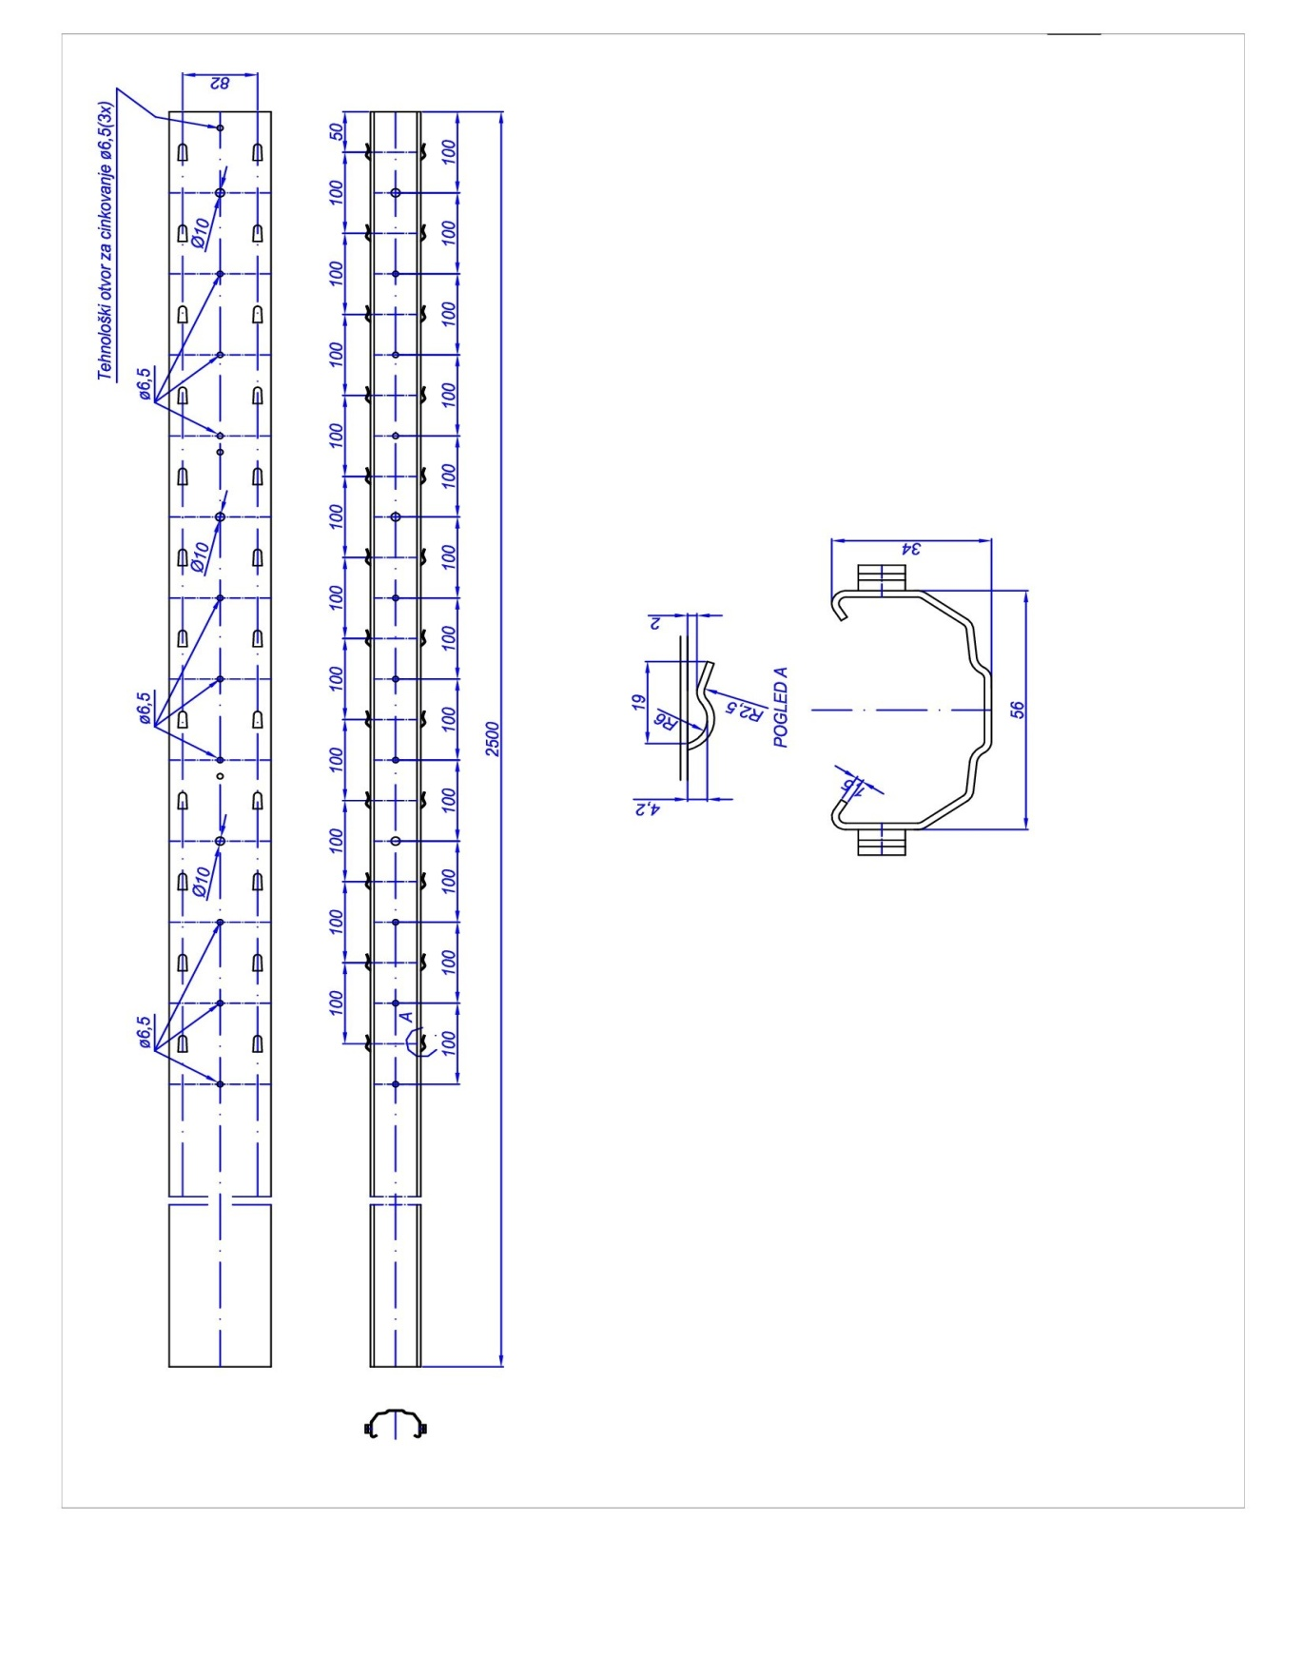

TECHNICAL CHARACTERISTICS OR SPECIFICATIONS OF THE SUBJECT OF THE PROCUREMENT, I.E. BILL OF QUANTITIES

Lot 2- Galvanized steel wire
Ord.No. | Description of the subject of the procurement, ie a part of the subject of procurement | Important characteristics of the subject of the procurement concerning quality, performances and/or measures | Unit of measure | Quantity
1 | Galvanized steel wire | Galvanized wire, diameter 2,5 mm  Tensile strength 400-500 N per mm²  Elongation 10% at stretch  Zinc coating 50-70 gr of zinc per m2 | kg | 35.000
2 | Galvanized steel wire | Galvanized wire, diameter 2,8 mm  Tensile strength 400-500 N per mm²  Elongation 10% at stretch  Zinc coating 50-70 gr of zinc per m2 | kg | 33.000

x Warranty time limit: min 15 years from the delivery date

x Manner of conducting quality control

-By providing the attest on the results of galvanization for each delivery or lot of the production of wire with zinc coating 50-70 gr zinc per mm². (testing report)

x Time limit : max 15 days from the day of the written order of goods

Procurer retains the right not to take over all quantities, specified by the technical characteristics of the concerned tender documentation, in case there is no need for it.

A qualitative receipt of the goods shall be made on the delivery day, during the validity of the Contract, for each delivery of goods, implying the control of parameters, given in the technical characteristics/specification and accepted bid by the Supplier.

TECHNICAL CHARACTERISTICS OR SPECIFICATIONS OF THE SUBJECT OF THE
PROCUREMENT, I.E. BILL OF QUANTITIES

Lot 3- Reinforcing bar
Ord.No. | Description of the subject of the procurement, ie a part of the subject of procurement | Important characteristics of the subject of the procurement concerning quality, performances and/or measures | Unit of measure | Quantity
1 | Bar | Reinforcing bar  Diameter Ø 8  Bars should be cut into piece  of 1 metre length  Steel category: B500B | piece | 250.000

x Warranty time limit: min 15 years from the delivery date

x Manner of conducting quality control

-By providing the attest for the delivered bars

x Time limit : max 15 days from the day of the written order of goods

x Supplier should deliver the reinforcing bars in the bundles of 1.000 or 2.000 pcs.

Procurer retains the right not to take over all quantities, specified by the technical characteristics of the
concerned tender documentation, in case there is no need for it.

A qualitative receipt of the goods shall be made on the delivery day, during the validity of the Contract,
for each delivery of goods, implying the control of parameters, given in the technical characteristics/
specification and accepted bid by the Supplier.

FORM OF THE BID WITH THE FORMS, PREPARED BY THE BIDDER

COVER PAGE OF THE BID

(title of the Bidder)
____________________________
Submits to

(title of Procurer)
_____________________

BID

By the Request for Collection of the Bids No._________ dated from__________year
for procurement

_______________________________________________________________
(description of the subject of the procurement)

FOR
□ subject of the procurement by lots

DATA ON THE BID AND BIDDER

Title and main office of the Bidder

Fiscal Identification Number

VAT

Account No and title of the Bidder’s bank

Address

Telephone

Fax

E-mail

Entity/-ies authorized for signing the financial part of the bid and documents in the bid | (Name, surname and function)
 | (signature)
Name and surname of the entity in charge for information

_____________________
₁
Or National Identification No.by the country which is the seat of the Bidder

FINANCIAL PART OF THE BID FOR LOT 1

Ord.No. | description of the subject | essential characteristics of the offered subject of procurement | measure unit | quantity |  | unit price without VAT | total amount without VAT
1
2
3
.....
Total price without VAT

Conditions of the Bid :
Time limit for the Contract execution
Place for the Contract execution
Manner and dynamics of delivery/execution
Guarantee time limit
Guarantee of quality
Manner of implementation of control quality
Time limit for payment
Method of payment
Validity period of the bid

Authorised entity of the Bidder
___________________________________
(name, surname and function)
_____________________________________
(signature by own hand)
PLACE OF SEAL

FINANCIAL PART OF THE BID FOR LOT 2

Ord.No. | description of the subject | essential characteristics of the offered subject of procurement | measure unit | quantity |  | unit price without VAT | total amount without VAT
1
2
3
.....
Total price without VAT

Conditions of the Bid :
Time limit for the Contract execution
Place for the Contract execution
Manner and dynamics of delivery/execution
Guarantee time limit
Guarantee of quality
Manner of implementation of control quality
Time limit for payment
Method of payment
Validity period of the bid

Authorised entity of the Bidder
___________________________________
(name, surname and function)
_____________________________________
(signature by own hand)
PLACE OF SEAL

FINANCIAL PART OF THE BID FOR LOT 3

Ord.No. | description of the subject | essential characteristics of the offered subject of procurement | measure unit | quantity |  | unit price without VAT | total amount without VAT
1
2
3
.....
Total price without VAT

Conditions of the Bid :
Time limit for the Contract execution
Place for the Contract execution
Manner and dynamics of delivery/execution
Guarantee time limit
Guarantee of quality
Manner of implementation of control quality
Time limit for payment
Method of payment
Validity period of the bid

Authorised entity of the Bidder
___________________________________
(name, surname and function)
_____________________________________
(signature by own hand)
PLACE OF SEAL

PROOFS OF THE FULFILLMENT OF MANDATORY CONDITIONS FOR PARTICIPATION INTHE PROCEDURE OF PUBLIC COMPETITION

To submit:

- proof of the registration, issued by the body, competent for the registration of the business companies with the data on the authorized persons of the Bidder;
- proof of the competent body, issued by the Criminal records that must not be older than six months until the day of the public opening of the bids, that a bidder, namely, its legal representative has not been convicted by final judgement for any of the criminal acts of the organized crime with the elements of corruption, money laundry and fraud;

PROOFS ON THE FULFILLMENT OF THE CONDITIONS OF THE ECONOMIC-FINANCIAL CAPABILITY

It is not required.

PROOFS ON THE FULFILLMENT OF CONDITIONS OF THE EXPERT-TECHNICAL AND PERSONNEL CAPABILITY

To be delivered for all 3 lots:

x the list of main deliveries, made in previous two years, with values, dates and receivers, with enclosing the confirmations of the effected deliveries, issued by Purchaser or in case that the confirmations cannot be provided for the reasons, not caused by bidder, only the statement of the bidder on the effected deliveries with the statement of the reasons for which they cannot submit the confirmations,
x measures for providing the quality management system:

- ISO 9001 standard
To be delivered for lot 1:
Bidder is obliged to enclose, on the memorandum of the producer, for Lot 1, against the bid the technical sheet of the post that he offers, corresponding to the drawing, found in the part ‘technical characteristics or specifications of the subject of the public procurement’.
The technical sheet of the post must be signed and sealed by bidder.

INSTRUCTIONS TO THE BIDDERS FOR MAKING AND SUBMITTING THE BIDS

Preparation of the bid
A bidder makes and submits the bid in compliance with this request for taking part in the procurement procedure.
Manner of submission of the bid
A bid is delivered in the appropriate, closed envelope (an envelope, box and similar). It is on one part of the envelope that the title and main office of the Procurer, number of the Request for Collection of the Bids and the text with the inscription: ‘Do not open before the public opening of the bids’ should be written, and on the other part of the envelope, the title, main office and the address of the Bidder should be written.
The bid shall be considered valid only if:
-All specified products, asked by the Request for Collection of the Bids are offered.
Manner of stating the offered price
A bidder submits the bid with the price (-s), expressed in EUR, without VAT, such as: unit price, quantity and total financial amount for the offered goods.
All costs and discounts, concerning the total offered price are included in the offered price.
Offered price (-s) is (are)expressed for the complete subject of procurement and if the subject of the procurement is classified by the lots, the financial part of the bid should be delivered for each lot, separately,for which the bid has been submitted.
Due time of the bid
A bid is considered submitted in due time if it is delivered to the Procurer prior to the expiry of the time limit, provided for submitting the bids, stipulated by this Request.
Recommendation to the bidders
A bid should be prepared as a single compound and each filled page of the bid should be numbered, signed and sealed.

