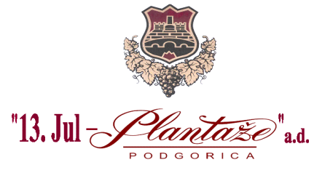
No: 6817/19/2
Place and date: Podgorica, 23.10.2019

Joint- stock company 13 Jul Plantaže A.D., Podgorica announces on the website :

MODIFICATIONS AND AMENDMENTS
OF THE REQUEST FOR COLLECTING THE BIDS
FOR THE PROCEDURE OF PROCUREMENT OF THE GOODS
FOOD FOR FISH

- Modification of the Request for Collecting the Bids for the Procedure of Procurement of the Goods Food for Fish ,in the part V Time limit and place of execution of the Contract,on page No.3.after the text : Place of the execution of the Contract, the following text is added: “EXW-Cologna Veneta-ITALY”.

Procurer announces the modifications and amendments to the related Request on the website: www.plantaze.com

Committee for Opening and Evaluation of the Bids ,
Head
Goran Milić,grad.lawyer

