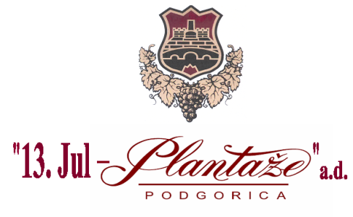

No: 2341/19/11
Podgorica, 03.07.2019.

MODIFICATIONS

of the Request for collecting the bids No.: 2341/19/10 dated from 25.06.2019. for the procurement of oak alternatives for the wine correction

The text of the Request has been modified in the following manner :

Instead of the text :

III manner of determination of the subject and estimated value of the procurement :

The subject of procurement is purchased as :

 a whole , estimated value €77.000,00, without VAT included .

This text should be written:

III manner of determination of the subject and estimated value of the procurement :

The subject of procurement is purchased as :

 a whole , estimated value € 80.000,00 , without VAT included .

Head of the Committee for
Opening and Evaluating of Bids
M.Sc. (Econ.) Milena Đurović

