13 Jul-Plantaže ad Podgorica

Register No: 61-6279-1

Ordinal No by the Plan of the Procurement:80

Place and date: Podgorica, 08.12.2017.

REQUEST FOR COLECTION OF THE BIDS FOR
THE PROCUREMENT PROCEDURE
of the machines for spring pruning

I Data on the Procurer

Procurer:  13 Jul Plantaže a.d. | Contact person:  Presiding of the Committee
Adress: Put Radomira Ivanovića br.2 | Postal No. 81000
Main office: Podgorica | Fiscal Ident.No.(Comp.Reg.No.).02016281
Tel: 0038220658 051 | Fax: 00382 20 658 051
E-mail: | goran.milic@plantaze.com

II Subject of the procurement

- Type of the public procurement subject

 Goods

- Description of the procurement subject

Procurement of the machines for spring pruning

III Manner of the determination of the subject and assessed value of the procurement
□ Assessed value of the procurement subject
The procurement subject is procured:
As a whole

Piston pumps for wine racking of the assessed value, VAT not included, 38.500,00 €, with VAT included amount 45.815,00 €.

TOTAL:
VAT not included: 38.500,00 €
with VAT included: 45.815,00 €

IV Conditions for taking part in the procurement procedure

a)Compulsory conditions
Only a bidder who meets the following requirements may take part in the procurement procedure :
- Must be registered with the competent public authority for the registration of the business entities;
- Must prove that he or his legal representative has not been convicted by judgement absolute for any criminal offence as members of the organized crime with the corruption, money laundry and fraud;

Proof of the fulfillment of the compulsory conditions
The fulfillment of the compulsory conditions shall be proved by submitting the following proofs:
- Proof on the registration with the competent public authority for the registration of the business entities with the data on the authorized persons of the bidder;
- Proof by the competent authority, issued on the grounds of the criminal record which must not be older than 6 months by the day of public opening of the bids;

b) Facultative conditions

b1) economic-financial capability
Fulfillment of the requirements of economic and financial capacity by submitting:
 Statements on accounting and financial state- profit and loss account and balance sheet with the report of the authorized auditor complied with the law, by which accounting and audit for the last 2 years, namely from the period of registration, have been defined;

b2) professional-technical and human resources capacity
Whether conditions of professional-technical and human resources capacity are met in the public procurement procedure for goods is evidenced by submitting one or more evidences, and so as follows:
  x measures for ensuring the quality management system:
ISO 9001
The bidder should submit the proof that he holds international standards for quality management system in business organization.

In case that bidder is not a manufacturer of the offered goods, he is obliged to deliver ISO 9001 system of the manufacturer for the goods which has been the subject of his bid.

x measures for ensuring the protection system at work :
OHSAS 18001
The bidder should submit the proof that he holds international standard for the health management system and safety at work.

In case that the bidder is not a manufacturer of the offered goods, he should submit OHSAS 18001, system of the manufacturer for the goods which is the subject of his bid.

x samples, descriptions, ie photos of the goods which are the subject of the delivery and the authenticity of which the bidder is obliged to confirm , in case that the Procurer requires it :

Technical sheet of the offered goods
Scheme of the offered machine for spring pruning
Scheme of the blade of the offered machine.

□x other certificates , confirmations, issued by the organs or bodies for the assessment of the compliance, the competence of which has been recognized and by which the adequacy of the goods is confirmed with clearly determined , related statement of the appropriate specifications or standards:

Declaration on the compliance of the production with:
- Directive 2006/42/EC
- UNI EN ISO 12100
- UNI EN ISO 12100-2
- UNI EN ISO 4413-2010

V Validity period of the bid

Validity period of the bid is 60 days from the day of the public opening of the bids.

VI Time limit and place of execution of the Contract

- Time limit for the execution of the Contract is 180 days from the day of the conclusion of the Contract.
Manner and dynamics of the delivery: delivery of completely specified quantity within 45 days from the day of the conclusion of this Contract.
-The place of the execution of the Contract is Procurer’s warehouse Podgorica.

Language of the bid

x Montenegrin language and other language, used officially in Montenegro in accordance with the Constitution and law
x English and Italian

VIII Criteria for the selection of the most favourable bid:

Criteria for the selection of the most favourable bid is:

□x economically the most favourable offer
1. Functional characteristics of the products- 25 points
2. Guarantee time limit- 15 points
3. Price- 60 points

Category 1 will be scored as follows:
- Material composition of which support and blades of the machine were made - 10 points
- Functionality of the machine- 10 points
- Hydro motor type – 5 points
Category 2 will be calculated by the formula: X offered/X max * number of points

Category 3 will be calculated by the formula:C the lowest price/ C offered price * number of points

IX Time limit and place of submitting the bids and opening of the bids

The bids shall be submitted on working days from 7 to 14 hrs, closing on the day of the year by the 21st of December 2017 at 12,00 hrs.

The bids may be submitted:

□ x directly, in person at the Procurer’s archive to the following address: Put Radomira Ivanovića No.2, 81 000 Podgorica, Montenegro.

□x by registered mail with the advice of receipt to the following address: Put Radomira Ivanovića No.2, 81 000 Podgorica, Montenegro.

Public opening of the bid, which may be attended by the authorized representatives of the bidders with enclosed power of attorney, signed by the authorized person, will be held on the 21st of December, 2017 at 12:30hrs in the premises of 13 jul-Plantaže a.d., located in Put Radomira Ivanovića Str, No.2, 81 000 Podgorica, Montenegro.

X Time limit for bringing a decision on the selection of the most favourable bid

The decision on the selection of the most favourable bid will be made within 30 days (from the day of the public opening of the bids).

XI Other data and conditions which are important for the implementation of the procurement procedure

The deadline and method of payment
The deadline is: 30% advance payment, 70% upon written notification that the goods is ready for delivery
Method of payment: by bank transfer upon delivered banking instructions

□The means of financial securing of the Contract on Procurement :
Prior to signing the contract, the bidder whose bid would be selected as the most favorable is obliged to provide the Procurer with the following:

□ x a guarantee for advance payment in the amount of the agreed advance with the validity period for the time period of total duration of the Contract.
□ x a good performance guarantee for the execution of the Contract in the amount of 5% of the contract value
TECHNICAL CHARACTERISTICS OR SPECIFICATIONS OF THE SUBJECT OF THE PROCUREMENT, I.E. BILL OF QUANTITIES

Ord.No. | Description of the subject of the procurement, ie a part of the subject of procurement | Important characteristics of the subject of the procurement concerning quality, performances and/or measures | Unit of measure | Quantity
1 | Machine for spring pruning | Technological characteristics  -Double vertical cutting tool and horizontal support  -Electronic remote control and hydraulic electro valve for hydraulic movement of the machine  - Slope and widening  - Foot for storing  - Blades, formed along the system, max.length 1950 mm  -Working height, made of wire 2 metres  -Working width, two bars: from 0,95 m to 3 metres  -Weight: cc 370 kg  -Horizontal top must have electro-hydraulic movements and adaptation to the working height and cutting angles.  -Two horizontal tops for cutting  -Horizontal upper height, working width and slope of the vertical bars are respectively adapted by electronic or hydraulic commands. Further adaptations are possible manually, as well.  -Electonic controls in the cabin are possible by electronic box or by joystick. Necessary possibility of adaptation in all 4 axes.  Oil flow: 25 litres  Provided independent hydraulic unit , capacity 60 litres with double pump, oil filter, high pressure valves and oil cooler.  It is necessary to adapt the production of the machine to the given technical drawings of:  - support of the blades of the machine  - position of the blades on the support  - post of the machine for spring pruning  - horizontal cutting | pieces | 5

x Guarantee period:
- minimum 12 months from the day of delivery of goods
- post guarantee maintenance 5 (five) years
x Manner of implementation of the quality control:
- Control of the delivered technical sheets with requested technical specification
- Control documents, based on the specific control EN 10204 standards
- Check-up of the functionality of the machine
x Guarantees of quality:
- Instructions for Use
- CE mark of the production
NOTE:
- The costs of installation and starting up of the concerned goods are included into the agreed price.
- Supplier will make available the team of his experts, on voluntary basis, during installing and starting up of the concerned goods.
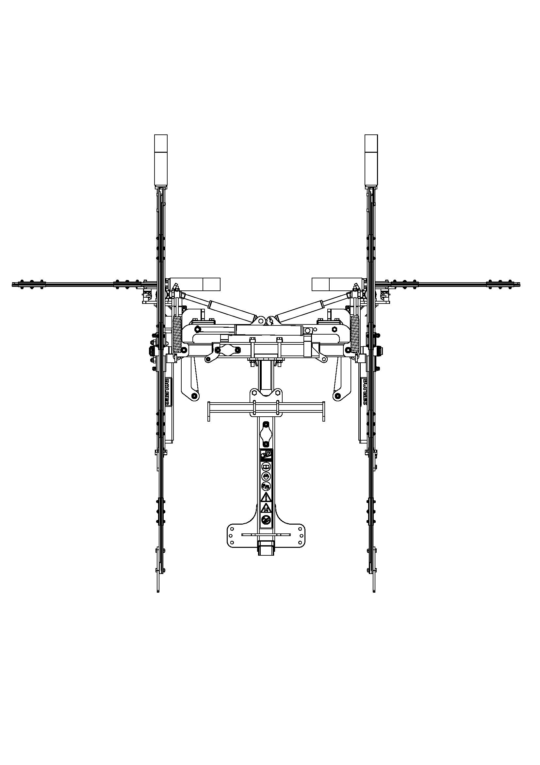
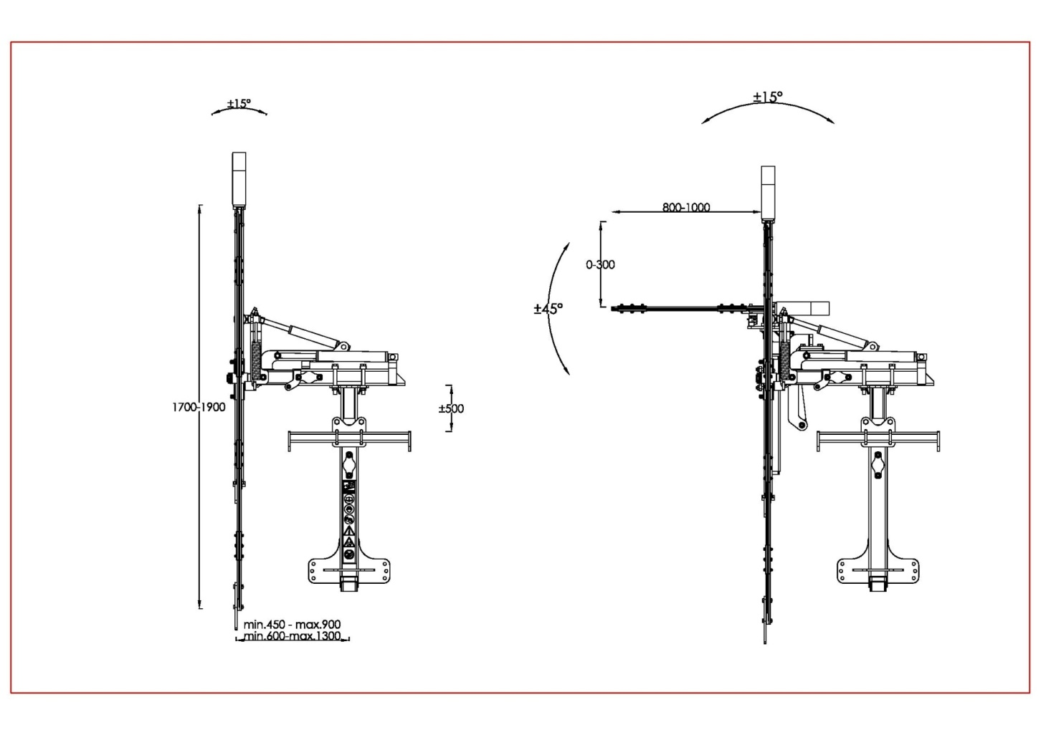
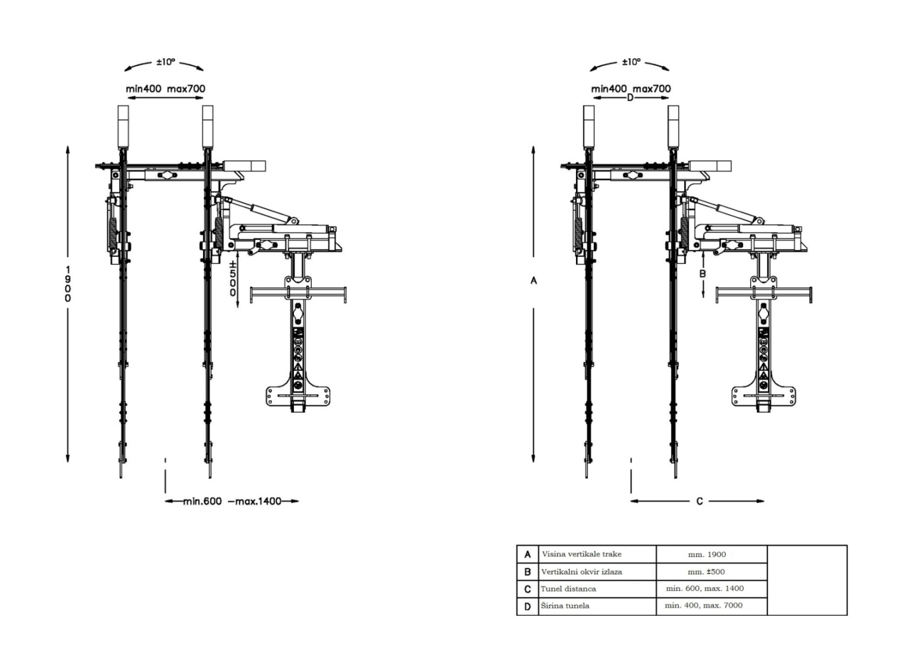
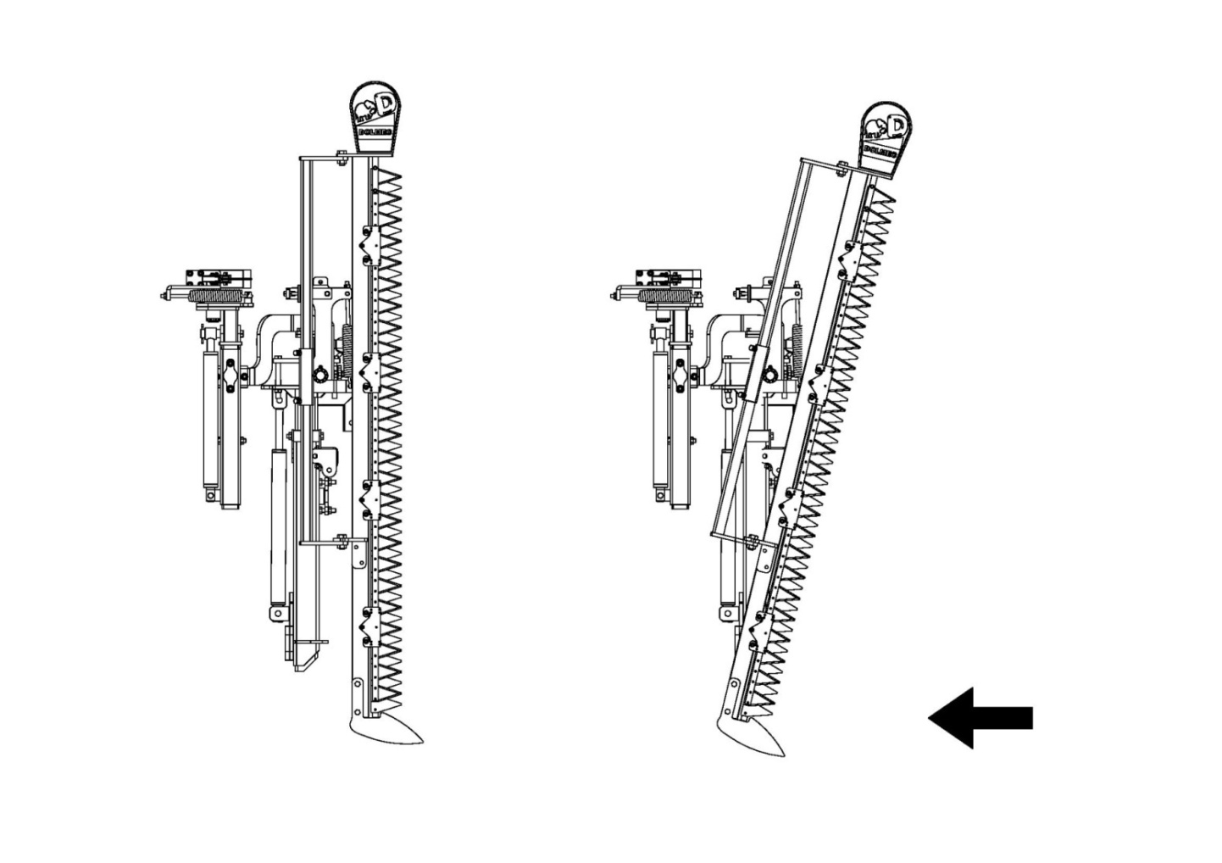

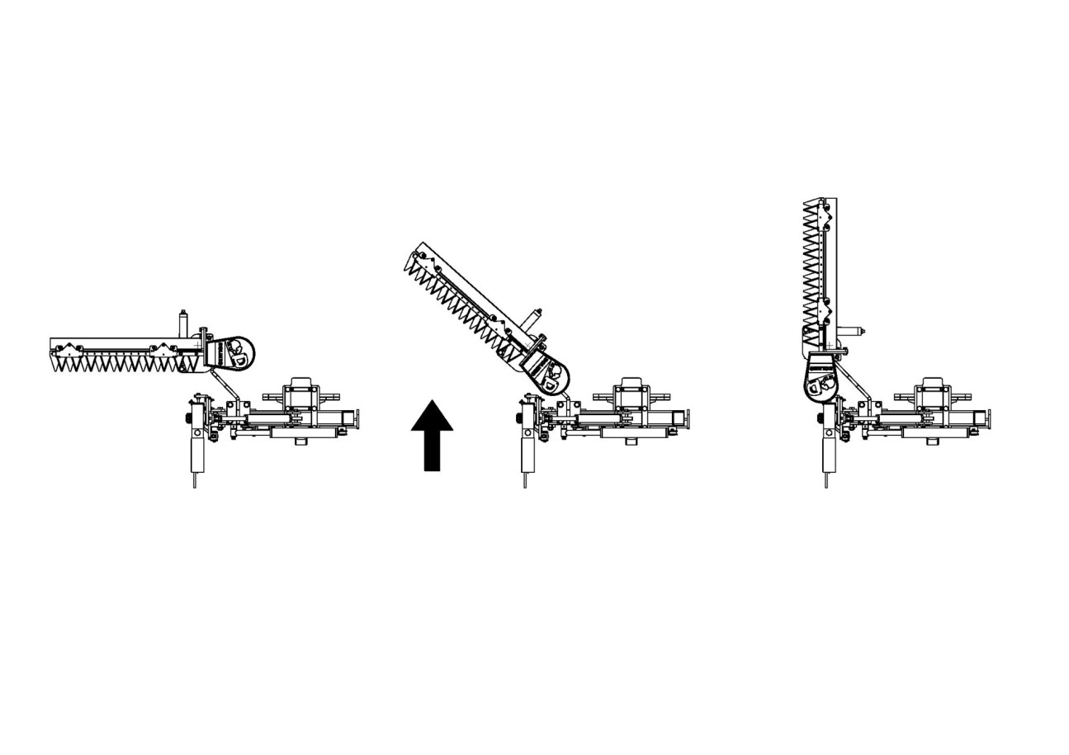

FORM OF THE BID WITH THE FORMS, PREPARED BY THE BIDDER

COVER PAGE OF THE BID

(title of the Bidder)
____________________________
Submits to

(title of Procurer)
_____________________

BID

By the Request for Collection of the Bids No._________ dated from__________year
for procurement

_______________________________________________________________
(description of the subject of the procurement)

FOR

□ subject of the procurement as a whole

DATA ON THE BID AND BIDDER

Title and main office of the Bidder

Fiscal Identification Number

VAT

Account No and title of the Bidder’s bank

Address

Telephone

Fax

E-mail

Entity/-ies authorized for signing the financial part of the bid and documents in the bid | (Name, surname and function)
 | (signature)
Name and surname of the entity in charge for information

_____________________
₁
Or National Identification No.by the country which is the seat of the Bidder

FINANCIAL PART OF THE BID FOR LOT 1

Ord.No. | description of the subject | essential characteristics of the offered subject of procurement | measure unit | quantity |  | unit price without VAT | total amount without VAT
1
2
3
.....
Total price without VAT

Conditions of the Bid :
Time limit for the Contract execution
Place for the Contract execution
Manner and dynamics of delivery/execution
Guarantee time limit
Guarantee of quality
Manner of implementation of control quality
Time limit for payment
Method of payment
Validity period of the bid

Authorised entity of the Bidder
___________________________________
(name, surname and function)
_____________________________________
(signature by own hand)
PLACE OF SEAL

PROOFS OF THE FULFILLMENT OF MANDATORY CONDITIONS FOR PARTICIPATION INTHE PROCEDURE OF PUBLIC COMPETITION

To submit:

- proof of the registration, issued by the body, competent for the registration of the business companies with the data on the authorized persons of the Bidder;
- proof of the competent body, issued by the Criminal records that must not be older than six months until the day of the public opening of the bids, that a bidder, namely, its legal representative has not been convicted by final judgement for any of the criminal acts of the organized crime with the elements of corruption, money laundry and fraud;

PROOFS ON THE FULFILLMENT OF THE CONDITIONS OF THE ECONOMIC-FINANCIAL CAPABILITY

Fulfillment of the conditions of the economic-financial capability will be proved by submitting:

□ x reports on accounting and financial balance- profit and loss account, balance sheet with the report of the authorized auditor in accordance with the law by which the accounting and audit have been regulated for the last two years, ie for the period from registration;

PROOFS ON THE FULFILLMENT OF CONDITIONS OF THE EXPERT-TECHNICAL AND PERSONNEL CAPABILITY

To submit:
□ x measures for securing quality management system

ISO 9011
The bidder should submit the proof that he holds international standards for quality management system in business organization.

In case that bidder is not a manufacturer of the offered goods, he is obliged to deliver ISO 9001 system of the manufacturer for the goods which has been the subject of his bid.

x measures for ensuring the protection system at work :
OHSAS 18001
The bidder should submit the proof that he holds international standard for the health management system and safety at work.

In case that the bidder is not a manufacturer of the offered goods, he should submit OHSAS 18001, system of the manufacturer for the goods which is the subject of his bid.

x samples, descriptions, ie photos of the goods which are the subject of the delivery and the authenticity of which the bidder is obliged to confirm , in case that the Procurer requires it :

Technical sheet of the offered goods
Scheme of the offered machine for spring pruning
Scheme of the blade of the offered machine.

□x other certificates , confirmations, issued by the organs or bodies for the assessment of the compliance, the competence of which has been recognized and by which the adequacy of the goods is confirmed with clearly determined , related statement of the appropriate specifications or standards:

Declaration on the compliance of the production with:
- Directive 2006/42/EC
- UNI EN ISO 12100
- UNI EN ISO 12100-2
- UNI EN ISO 4413-2010

DRAFT OF THE CONTRACT ON THE PUBLIC PROCUREMENT OF THE MACHINE FOR SPRING PRUNING
This Contract is concluded between:

Procurer , 13 jul-Plantaže a.d. Podgorica, Put Radomira Ivanovića No.2, Company Registration No/Tax identification No 02016281,VAT: 20/31-00021-4, Giro account No: 550-1092-08 at Societe Generale Montenegro, represented by the executive director Verica Maraš, grad.econ.(hereinafter referred to as: PROCURER), on one hand and

Bidder ______________________based in_____________, address________________________
Registration No: ___________Tax Identification No: _______________, giro account No:_________
at_________________bank, represented by _____________(hereinafter referred to as :SUPPLIER), on the other hand.

Preliminary procedures to the Contract have been implemented by the open procedure and the contracting parties have agreed as follows:

BASE OF THE CONTRACT
Tender documentation for the open procedure of the procurement of the machine for spring pruning,complied with the technical characteristics or specification, enclosed in the tender documentation, No._______/17, dated from _____ 2017.
Decision on the selection of the most favourable bid No. ______dated from_____________2017..
Bid of the bidder No._______________dated from:______________2017.

Article 1
The subject of this Contract is the procurement and delivery of the machines for spring pruning, complied with the technical characteristics/ specification, enclosed in the tender documentation No:___________/17, dated from _________2017, Decision on the selection of the most favourable bid No. ______dated from_____________2017 and accepted Bid of the Supplier No._______________ dated from:______________ 2017 which makes the integral part to this Contract.
Article 2
Supplier is obliged to deliver the concerned goods, pursuant to Art.1 of this Contract to the Procurer, complied completely with the technical characteristics /specification and other conditions from the accepted bid such as:
Machine for spring pruning, 5 pieces with the following characteristics:
-Double vertical cutting tool and horizontal support
-Electronic remote control and hydraulic electro valve for hydraulic movement of the machine
- Slope and widening
- Foot for storing
- Blades, formed along the system, max.length 1950 mm
-Working height, made of wire 2 metres
-Working width, two bars: from 0,95 m to 3 metres
-Weight: cc 370 kg
-Horizontal top must have electro-hydraulic movements and adaptation to the working height and cutting angles.
-Two horizontal tops for cutting
-Horizontal upper height, working width and slope of the vertical bars are respectively adapted by electronic or hydraulic commands. Further adaptations are possible manually, as well.
-Electonic controls in the cabin are possible by electronic box or by joystick. Necessary possibility of adaptation in all 4 axes.
-Oil flow: 25 litres
-Provided independent hydraulic unit , capacity 60 litres with double pump, oil filter, high pressure valves and oil cooler.
-It is necessary to adapt the production of the machine to the given technical drawings of:
*support of the blades of the machine
*position of the blades on the support
*post of the machine for spring pruning
*horizontal cutting
Article 3
The total value of the goods complied with the accepted bid-proof the Supplier No:____ dated from _______year , amounts _____________€ with included VAT(read as:______________Euros).
The contracting price is fixed and unmodified for the validity period of the Contract.
The costs of assembly and start up of the concerned goods are included in the contracting price.

Article 4
Supplier is obliged to effect the delivery of the whole concerned goods within 45 days from the day of the conclusion of the Contract, Procurer’s warehouse, Podgorica.
Parity of delivery is DAP Podgorica (Incoterms 2010).
Parity of delivery for a foreign entity (foreign supplier), concerning the payment of VAT may be determined pursuant to Art. 12, par.1, point 2 Law on the Value Added Tax (Official Gazette of Republic of Montenegro, No. 65/01….04/06 and Official Gazette No.16/07, 40/11), by which it is defined,as follows:
As far as a foreign entity, operating its business activities in Montenegro through a business unit, is concerned in accordance with the Art.28 of the Rules on Application of VAT (Official Gazette Republic of Mne, No. 65/02…..16/06, 64/08), that business unit shall calculate and pay VAT, in accordance with the Rules ( Business unit of a foreign entity represents in the name and on behalf of a foreign entity and it must use the firm of the mother enterprise,its seat and its title);
Pursuant to Art.12 and in accordance with the par.3 of the Law on Value Added Tax, a foreign person which is not obliged, in accordance with the regulations, to establish a business unit and effects the turnover in Montenegro, it is entered into the Register of Tax payers for VAT and may appoint the tax representative who will ,in his name, settle all the obligations, stipulated by the Rules.
Pursuant to Art.12, par.2 Law on Value Added Tax, if a tax payer who does not have the main office in Montenegro, does not appoint its tax representative, VAT shall be paid by the receiver of the products, ie services(Procurer).
Delivery of goods will be effected and confirmed by the written act on transfer.
Contracting parties agree that the qualitative and quantitative receipt of the concerned goods shall be done at the place (warehouse) of the Procurer and at the moment of taking over the goods by Procurer, by which the delivery shall be considered completed, provided there have not been any comments by Procurer.
Supplier will make available its experts team, on voluntary base, during installation and start up of the concerned goods.

Article 5

Supplier of goods is obliged that the quality of goods shall be completely in accordance with the EU regulations related to this field and that the quality of the concerned goods shall be completely identical with the requested technical characteristics/specification and accepted Supplier’s offer.
Contracting parties agree that the delivery of the concerned goods will be the subject of the receipt quality control, complied with the control plans of the Procurer.
Supplier will make available its experts team, on voluntary base, during installation and start up of the concerned goods.
Article 6
Supplier is obliged to deliver to the Procurer from the Manufacturer of the concerned goods:
-ISO 9001 as the proof that it holds the international standard for the quality management system in the business organization.
In case that the bidder is not a manufacturer of the offered goods, he is obliged to enclose ISO 9001 system of the Manufacturer of goods which is the subject of its bid.
-Certificate OHSAS 18001 as the proof that it holds the international standard for the health management system and safety system at work.
-Technical list of the offered goods
-Scheme of the offered machine for spring pruning
-Scheme of the blade of the offered machine
Declaration on the compliance of the production with:
-Directive 2006/42/EC
- UNI EN ISO 12100
- UNI EN ISO 12100-2
- UNI EN ISO 4413-2010
Article 7
Guarantee time limit for the concerned goods is 12 months minimum from the delivery of the concerned goods .
Supplier is obliged to remove, at his own expense, all defects that may occur within the guarantee time limit, in case that the defects have been in compliance with the guarantee conditions.
In case that Supplier does not act in compliance with the par.1 of this Article, Procurer has the right, at the Supplier’s cost, to engage the other entity for removing all defects at the concerned goods and Supplier is obliged, within 10 days from the day of delivering the invoice to the Procurer from the other party, to effect the payment of the invoiced amount for the works which that other entity executed for removal of the defects at the concerned goods which were the obligation of the Supplier.

Article 8
Contracting parties agreed that post guarantee maintenance is 5 (five) years from the day of delivery of the concerned goods and that the Supplier is obliged to provide the maintenance of the concerned goods and spare parts (regular service, delivery of the new spare parts that are compatible to the concerned goods and included in the Manual for the concerned goods) in the determined post-guarantee period, at Procurer’s expense, and based on the invoice of the Supplier which he will issue to the Procurer by fair and producer’s prices.
Supplier will effect , in the determined post guarantee time limit ,the maintenance of the concerned goods up to the amount which is stated in the accepted bid No.:________ dated from _________2017.
Article 9
Manner of the quality control implies:
- Control of the delivered technical sheets with the asked technical specification
- Control of the document, based on the specific control EN 10204 standard
- Check of the machine functionality
Guarantee of the quality:
- Instructions for use
- CE mark of the production
Article 10
In the case that the Procurer determines ,at the receiving control, that the quality of the concerned goods which is the subject of this Contract, deviates from the agreed quality, namely from the offered quality in the Bid, he draws up the Claim Minutes and notifies the Supplier of the return –claim on goods which has arrived at the Procurer’s warehouse.
In case of any doubt in the quality of the delivered goods, based on the use of such goods in the production process, Procurer notifies the Supplier of the stated defects and problems.Supplier is obliged to send his representative within 48 hours , an expert, responsible person who will, together with the responsible person of the Procurer determine the problem that occurred and draw up the mutual Minutes on further handling with the goods.
In case that the Supplier does not respond to the call in due time and the mutual Minutes is not drawn up, it shall be considered that he has accepted the claim of the goods. In case of return of the delivery, Supplier is obliged, within 45 days, at the latest, to deliver a new quantity of goods and remove the defects that occurred.
Three claimed deliveries shall be the legal grounds for the termination of this Contract.

Article 11
In the case that the Supplier does not deliver the goods upon the claim, described in the Art. 10 of this Contract and in case that the circumstances , determined by the Art.12 of the Contract, occur ,he is obliged to compensate the damage to the Procurer in the manner, as defined by the Art.14 of the Contract and he retains the right to realize the submitted bank guarantee for the advance payment and bank guarantee for the good performance of work as well as refunding of the paid means that Procurer has previously paid upon receiving the written notification by the Supplier that the concerned goods is ready for delivery.

Article 12
In case that Supplier delivers to the Procurer the concerned goods of the inappropriate quality for three times, the Contract immediately stops to be valid (terminates), Procurer does not have any obligation of paying the invoiced price of the concerned goods and Supplier bears the responsibility and sanctions, pursuant to the Art.14 of the Contract.

Article 13
The place of execution of the Contract, ie the place of the delivery of the goods is the warehouse of Procurer, Podgorica.

Article 14
In the case that the Supplier does not deliver the concerned goods to the Procurer within the time limit, pursuant to the Art.4 of this Contract,he is obliged to pay to the Procurer the contractual penalty for each day of delay in the amount of 2% of the total value of the ordered goods.
In case that Supplier does not deliver the concerned goods at all, he is obliged to compensate for the real and suffered material damage to the Procurer due to the undelivered goods and Procurer retains the right for the realization of the submitted bank guarantee for the advance payment for the goods and bank guarantee for good performance of work as well as the refunding of the paid means that Procurer has previously paid upon receiving the written notification by the Supplier that the concerned goods is ready for delivery.
The level of the material damage shall be determined by the Committee, consisted of 4 (four) experts, out of whom 2 (two) by the Procurer and 2 (two) by the Supplier of which they will draw up the Minutes, signed by the Committee.
Supplier will compensate to the Procurer a certain level of the material damage within 30 (thirty) days commencing from the day of the appraisal of the material damage.
In case that the parties do not agree on the appraisal of the material damage, it shall be the subject of court decision making at the Economic court in Podgorica.
Article 15
Procurer is obliged to effect the payment of the agreed price by bank transfer , as follows:
-30% advance payment, upon submission of the bank guarantee for the advance payment by Supplier with the validity time limit , within the total duration of the Contract.
-70% upon the written notification by Supplier that the concerned goods is ready for delivery.
Article 16
Supplier is obliged to submit to the Procurer , at the moment of signing this Contract, irrevocable, unconditional and at first call payable bank guarantee for the good execution of the Contract in the amount of 5% of the total value of the Contract with the validity period 30 (thirty) days longer than the validity period of this Contract pursuant to Art.20 of this Contract and which may be activated by Procurer, at any moment when any of the reasons for the termination of the Contract occur.
The guarantee must be issued by a business bank of the Supplier, located in Montenegro or by the business bank of the Supplier, located in any foreign country which will be reliable for the collection by a bank guarantee.
Procurer is obliged to return to the Supplier the submitted bank guarantee for good execution of the Contract,directly and within the time limit, immediately upon the fulfillment of the contractual obligations, namely, upon good execution of the Contract by Supplier, in the manner and by the conditions from this Contract and without any remarks by Procurer.
Article 17
Supplier states and guarantees to the Procurer, under the threat of criminal and substantive responsibility of the legal person and its signatory the following:
-That it has been legally founded and registered as the legal person and the business company complied with the regulations of the country where it has its registered seat.
-That it may conclude legally and with full force this Contract as well as all other legal instruments concerning the Contract.
-That the signatory of the Contract has all the authorities for the Contract conclusion pursuant to the legal regulations of the country where it has its registered seat.
Article 18
The contracting parties shall not be obliged to execute their obligations in accordance with this Contract during the force majeure, such as: war and war action and natural disasters (fire, flood,mobilisations, explosion and other natural disasters,declared by the state as such), in case that the non-fulfillment of the stated obligations has been caused by the occurrence of force majeure and provided that they notify, immediately,within three working days, at the latest, the other contracting party of the occurrence of force majeure.
Otherwise, the contracting party to which the occurrence of force majeure relates, cannot refer to it unless it notifies the other contracting party of the action of force majeure,except in the case when the circumstance of force majeure prevents him to send such a notice.
The contracting party, not affected by the force majeure is entitled to unilateral termination of the Contract in case that the action of force majeure lasts over two months commencing from the day of giving such a notice to the other contracting party.
Article 19
The interpretation of the Contract by the contracting parties will be based on the principle of consciousness and fairness,as the basic principle of the obligations’ relations.
With the signatures on this Contract, the contracting parties confirm that the conditions of the Contract are comprehensible and clear to them and that the Contract has been concluded with the good will of the contracting parties,without any force and compulsion.
The contracting parties agree that the provisions of the Contract must be interpreted in accordance with the provisions of the Positive legal regulations which are effective in Montenegro.
Article 20
This Contract is concluded for the period of 180 (one hundred and eighty) days and is applicable from the day of its conclusion.
This Contract may be terminated unilaterally also before expiry of the time period for which it has been concluded, if one of the contracting parties does not execute its contractual obligations.
Procurer is entitled to terminate the Contract unilaterally in case that Supplier:
-does not execute its obligations within the time limits and in the manner, stipulated by this Contract
-when Supplier determines that the quality of the goods which is the subject of this Contract or the manner by which the goods is delivered deviates from the agreed, namely offered quality from the Supplier’s bid
- does not follow the agreed method and time limit of the delivery
- and in other cases, stipulated by this Contract.
Termination of the Contract does not release Supplier from the compensation of the damage, defined in the Art. 14 of this Contract as well as from the realization of the delivered bank guarantee for the advance payment of goods and bank guarantee for good performance of work as well as refunding for the paid means which the Procurer has previously paid upon receiving of the written notification by Supplier that the concerned goods is ready for delivery.
Supplier is entitled to unilateral termination of the Contract in case that the Procurer does not effect the payment for the invoiced price in the determined time limit, namely within the time limit, denoted in the Supplier’s invoice,as well as in other cases, stipulated by this Contract.

Article 21
In case of any status modifications by the contracting parties during the validity period of this Contract, all rights and obligations of the contracting party at which the modification occurred, shall be assigned to its legal inheritor.
The contracting parties are obliged to notify immediately the other contracting party in the written form about the occurrence of status changes, if any, upon the conclusion of this Contract.
Article 22
The contracting parties agree that the provisions of the Law on Obligations of Montenegro and other Positive law regulations,valid in Montenegro, shall be applied on any matters,not defined by this Contract.
Article 23
The contracting Parties agree to settle the disputes amicably, if any, and otherwise, the Economic courtin Podgorica shall be competent.
Article 24
Supplier is obliged to sign this Contract within 8 (eight) days, commencing from the day of its taking over, namely, delivery and within the same time limit he is obliged to return to the Procurer the signed Contract with the bank guarantee, defined in the Art.16 of this Contract.
In case that Supplier refuses to conclude the Contract, Procurer is entitled to claim the compensation of the damage by Supplier in the amount of 10% of the agreed amount and Supplier is obliged to compensate the damage within 10 days.

Article 25
The Contract is made in 6 (six) identical copies, 3 (three) copies for each contracting party, respectively.
Article 26
Contracting parties have read this Contract and accordantly, state that this Contract is the expression of their free wills and that none of them are under fraud, threat, force, illusion and similar, so they put their signatures by their own hand as the sign of its legal validity.

PROCURER, SUPPLIER,
13 Jul-Plantaže ad Podgorica
Executive director

Verica Maraš, grad.econ. _________________

I AGREE WITH THE DRAFT OF THE CONTRACT
Authorised person of the bidder__________________
(name and surname)
_______________________
( position)

- Note: The final text of the Contract on Procurement and Delivery of the Machine for Spring Pruning shall be made in accordance with the Bidder, the Bid of which has been selected as the most favourable.

INSTRUCTIONS TO THE BIDDERS FOR MAKING AND SUBMITTING THE BIDS

Preparation of the bid
A bidder makes and submits the bid in compliance with this request for taking part in the procurement procedure.
Manner of submission of the bid
A bid is delivered in the appropriate, closed envelope (an envelope, box and similar). It is on one part of the envelope that the title and main office of the Procurer, number of the Request for Collection of the Bids and the text with the inscription: ‘Do not open before the public opening of the bids’ should be written, and on the other part of the envelope, the title, main office and the address of the Bidder should be written.
The bid shall be considered valid only if:
-All specified products, asked by the Request for Collection of the Bids are offered.
Manner of stating the offered price
A bidder submits the bid with the price (-s), expressed in EUR, without VAT, such as: unit price, quantity and total financial amount for the offered goods.
All costs and discounts, concerning the total offered price are included in the offered price.
Offered price (-s) is (are)expressed for the complete subject of procurement and if the subject of the procurement is classified by the lots, the financial part of the bid should be delivered for each lot, separately,for which the bid has beensubmitted.
Draft of the Contract on Procurement
A bidder is obliged to enclose in the bid a Draft of the Contract on the Procurement, sealed and signed by the authorized entity in the place, provided for making an approval for it.
Due time of the bid
A bid is considered submitted in due time if it is delivered to the Procurer prior to the expiry of the time limit, provided for submitting the bids, stipulated by this Request.
Recommendation to the bidders
A bid should be prepared as a single compound and each filled page of the bid should be numbered, signed and sealed.

