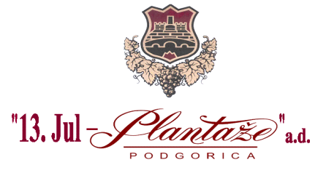

No: 6583/18/2
Place and date: Podgorica, 17/12/2018

„13 Jul Plantaže” A.D., Podgorica announces on the website:

AMENDMENTS
TO THE REQUEST FOR COLLECTING THE BIDS
FOR THE PROCUREMENT PROCEDURE
of the galvanised metallic wires and galvanised metallic posts

- Modifications to the Request for Collecting the Bids for the Procurement Procedure of the Goods –galvanised metallic wire and galvanised metallic posts have been done on the page No.3/42 in the section ‘ Measures for providing the Quality Management System’ , as follows:

It is added:

“ A bidder should submit the proof of holding the international standard for the quality management system in the business organization.In case that the bidder is not a manufacturer of the offered goods, he is obliged to submit ISO 9001 system of the manufacturer for the goods which is the subject of his bid.’’

Procurer shall announce the amendments to the related Request on the website www.plantaze.com

Committee for opening and evaluation of the bids ,
Head,
Goran Milić, grad.lawyer, head

